***Dt : 18/5/2022***

***\*imp***

***define 'import' statement?***

***=>'import' statement is used to make class or interface available***

***one package to another package.***

***=>This importing process in Java can be done in three ways:***

***(i)Using 'import package_name.CName/IName; '***

***(ii)Using 'import package_name.*; '***

***(iii)using 'Fully Qualified Names'***

***(i)Using 'import package_name.CName/IName; '***

***=>In this importing process we specify the required Class_name***

***or Interface_name to be available for current running program.***

***Ex:***

***import java.util.Scanner;***

***import p2.StudentResult;***

***(ii)Using 'import package_name.*; ':***

***=>In this importing process all the Classes and Interfaces***

***from the package are available to Current running program.***

***Ex:***

***import java.util.*;***

***import p2.*;***

***(iii)using 'Fully Qualified Names':***

***=>The process of declaring Classes and Interfaces with package***

***names part of programming code is known as 'Fully Qualified Names'***

***Ex:***

***java.util.Scanner s = new java.util.Scanner(System.in);***

***p2.StudentResult sr = new p2.StudentResult();***

***=======================================================***

***faq:***

***define 'static' import?***

***=>The process of declaring import statement with 'static'***

***keyword is known as static import and which is introduced by***

***Java5 version.***

***syntax:***

***import static package_name.CName/IName.*;***

***Advantage:***

***=>when we use 'static import' then all the static members of***

***Class or Interface available to current running program and can***

***be accessed directly without Class_name or Interface_name.***

***define sqrt() method?***

***=>sqrt() is a Pre-defined static method available from***

***java.lang.Math class and which is used to find the sqrt of given***

***number.***

***Method Signature:***

***public static double sqrt(double);***

***syntax:***

***double result = Math.sqrt(var);***

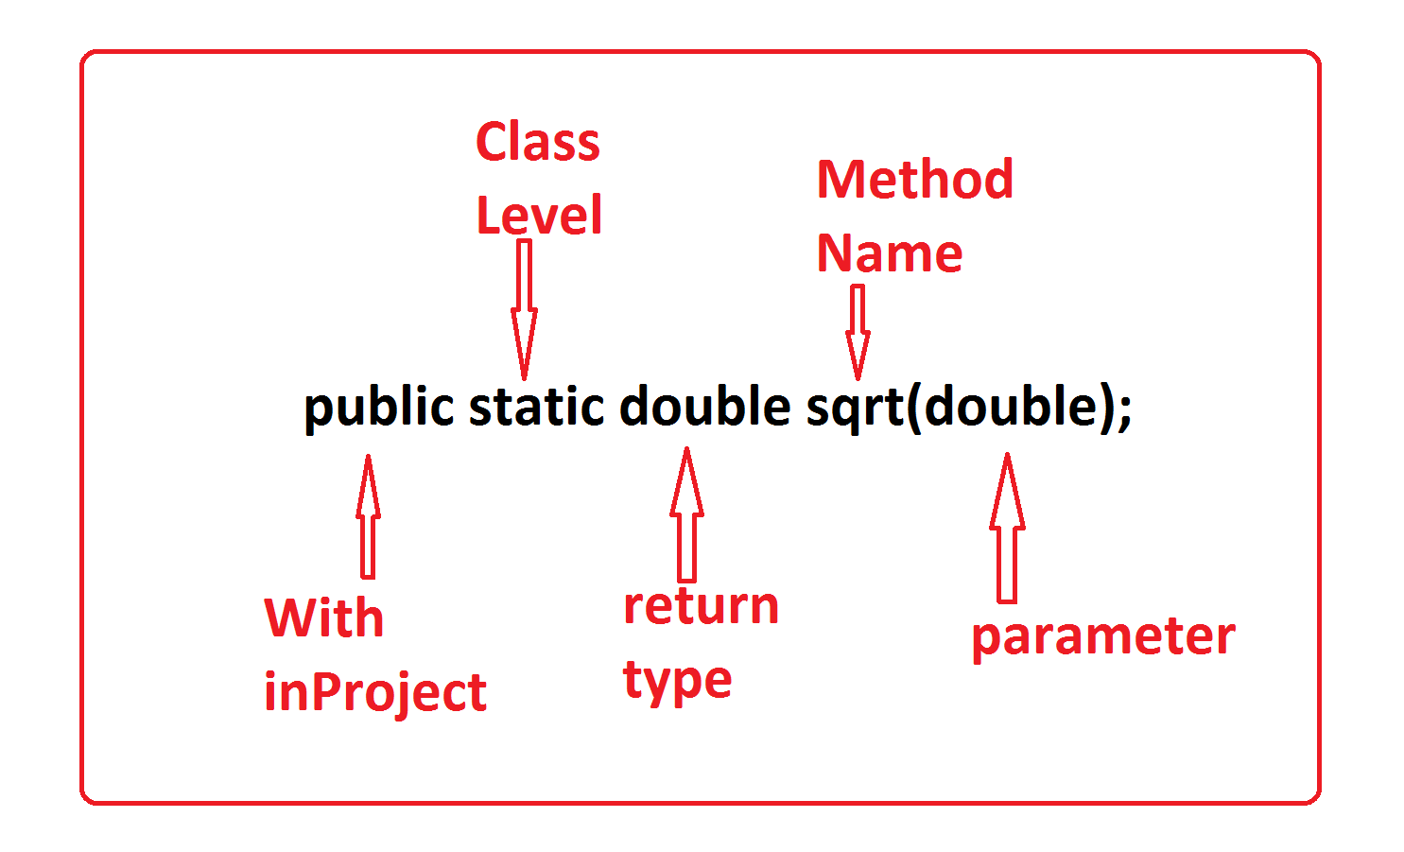

***Program : DemoStatic.java***

***package p1;***

***import java.util.Scanner;***

***import static java.lang.Math.*;***

***public class DemoStatic {***

***public static void main(String[] args) {***

***Scanner s = new Scanner(System.in);***

***System.out.println("Enter the value:");***

***double val = s.nextDouble();***

***double result = sqrt(val);//Calculating_sqrt***

***System.out.println("Result:"+result);***

***s.close();***

***}***

***}***

***o/p:***

***Enter the value:***

***234***

***Result:15.297058540778355***

***=========================================================***

***faq:***

***define Access Modifiers in Java?***

***=>Access Modifiers specify the visibility of programming***

***Components within the Project.***

***=>The following are some important access modifiers from Java:***

***1.public***

***2.private***

***3.protected***

***4.default***

***1.public:***

***=>public programming components are accessed within the project***

***folder.***

***2.private:***

***=>private programming components are accessed only inside the***

***class.***

***3.protected:***

***=>protected programming components are accessed within the***

***package.***

***Note:***

***=>In inheritance process,protected programming components of***

***ParentClass are available to ChildClass declared outside the***

***package.***

***4.default:***

***=>default programming components are accessed only inside the***

***package.***

***Note:***

***=>The programming components in Class which are declared without***

***any access modifier then it is considered as default.***

***=>There is no concept of 'default' keyword in classes.***

***Diagram:***



